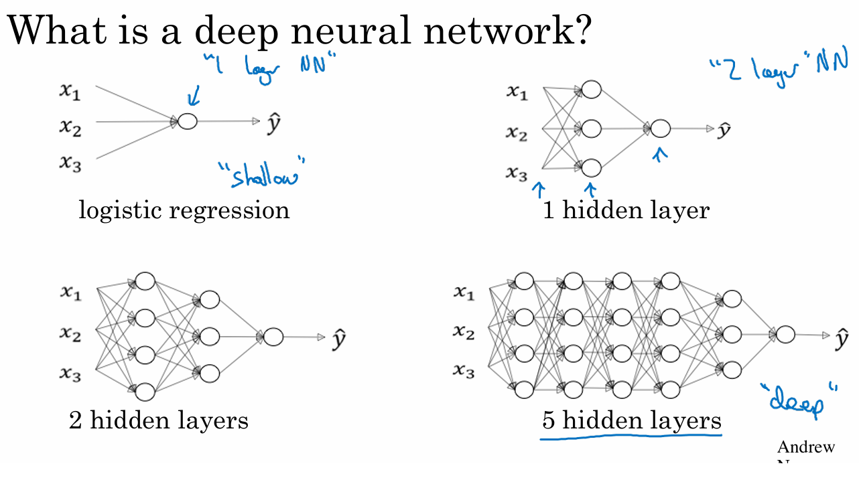
- Logistic regression is considered a shallow model.
- A neural network with one hidden layer is still shallow but deeper than logistic regression.
- Deep networks add multiple hidden layers.
- Machine learning research shows deep networks can learn functions that shallow models cannot efficiently learn.
- Depth selection (number of hidden layers) is a hyperparameter and should be tuned using dev/validation sets.
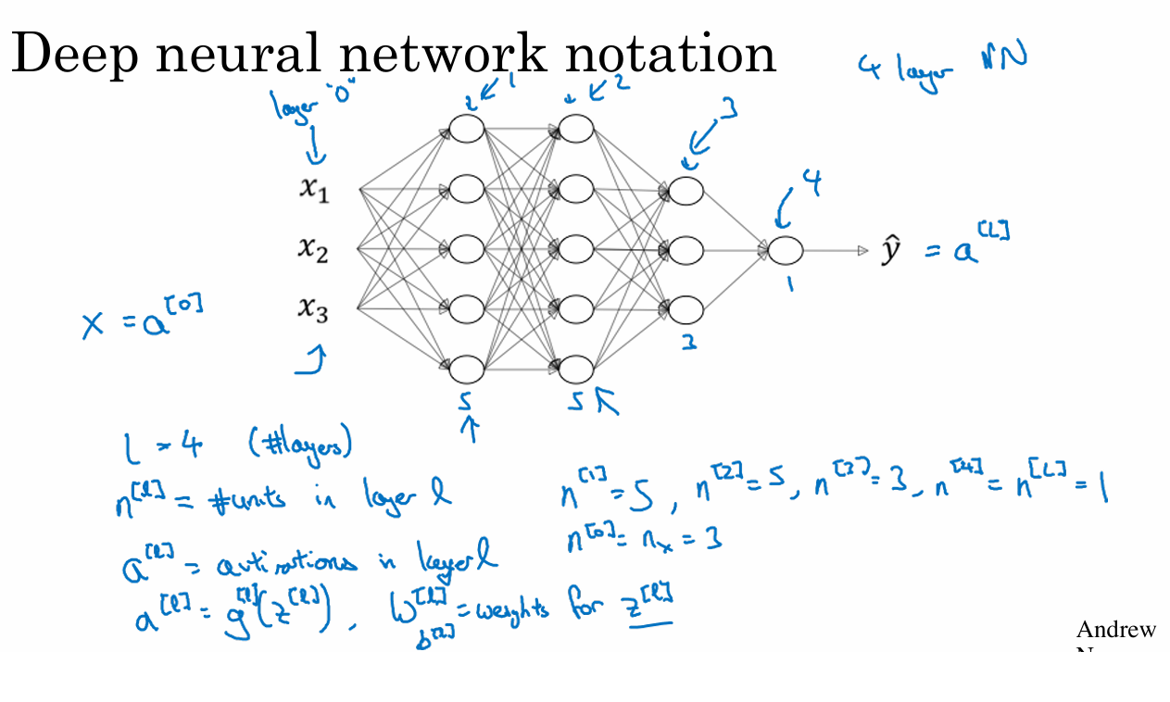
- Notation for deep neural networks:
  - L = total number of layers (excluding input layer).
  - n[l] = number of units in layer l.
  - a[l] = activations in layer l.
  - W[l], b[l] = parameters for layer l.
  - a[0] = x (input features).
  - a[L] = ŷ (output of the network).
- Example network described: input layer → three hidden layers (sizes 5, 5, 3) → output layer (1 unit).

